Ain Shams University

Faculty of Engineering

CHEP- CESS

Mohammed Ehab Elsaeed

16P8160

m.elsaeed1998@gmail.com

Electronic Design Automation

CSE 215

Digital Access Control Finite State Machine Project 2

Introduction

The purpose of this document is to illustrate the usage of Alliance tools to synthesise the digital access control finite state machine created in project one.

Table of Contents

1. Code Modification for Alliance
2. BOOM Outputs Comparison
3. BOOG Outputs Comparison
4. LOON Outputs Comparison
5. LOON Netlist of Chosen State Encoding
6. Delay Simulation After FLATBEH and PROOF.
7. SCAPIN Netlist
8. Simulation of FSM Using the Behavioural Component, and LOON’s and SCAPIN’s structural Components.
9. Test of scan-path
10. Appendix
    1. Makefile
    2. Paramfile
    3. .path file
    4. FLATBEH log
    5. PROOF log
    6. LOON’s and SCAPIN’s Structural Components and FSM’s Behavioural Component Comparison-Based-Testbench

1- Code Modification for Alliance

For Alliance tools to work, I had to make a slight modification to my FSM’s VHDL Code.

For Alliance:

                when others =>

                    assert ('1')

                    report "Invalid state";

For Symphony EDA (ModelSim Equivalent):

                when others =>

                    assert false

                    report "Invalid state"

                        severity failure;

SYF never accepted the “assert false” statement.

2- BOOM Outputs Comparison

|  |  |  |  |  |  |
| --- | --- | --- | --- | --- | --- |
| Encoding | A | J | M | O | R |
| Final Literals | 92 | 95 | 78 | 100 | 90 |

3- BOOG Outputs Comparison

|  |  |  |  |  |  |
| --- | --- | --- | --- | --- | --- |
| Encoding | A | J | M | O | R |
| Critical Path Delays | 2302 | 2032 | 2112 | 2508 | 2213 |
| Areas | 79500 | 84000 | 70000 | 98000 | 78750 |

4- LOON Outputs Comparison

|  |  |  |  |  |  |
| --- | --- | --- | --- | --- | --- |
| Encoding | A | J | M | O | R |
| Critical Path Delays | 2363 | 3156 | 2584 | 3022 | 3015 |
| Areas | 80750 | 86250 | 70250 | 103000 | 82000 |

Decision: Encoding **M** was chosen.

Justification: It has the lowest area and the 2nd lowest delay among other encodings.

Paramfile is in the appendix.

5- LOON Netlist of Chosen Encoding

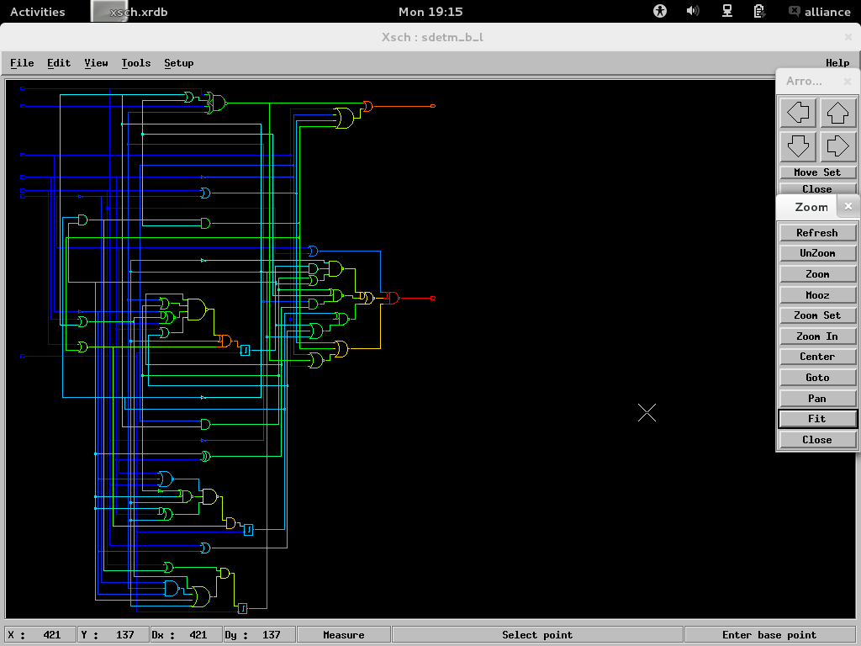

6- Delay Simulation After FLATBEH and PROOF.

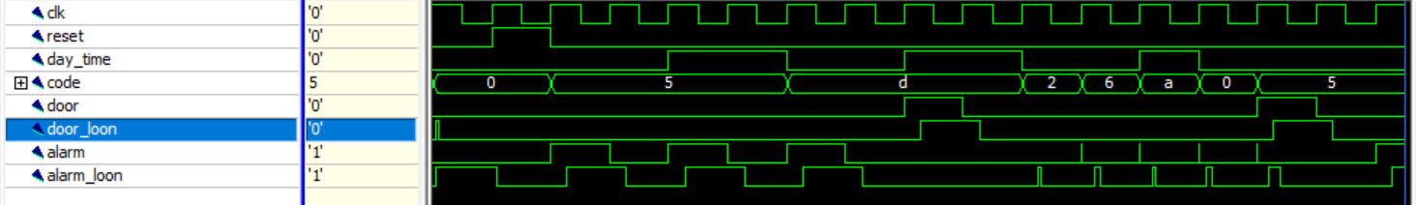

Terminal Output:

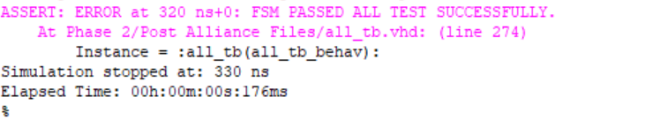

7- SCAPIN Netlist

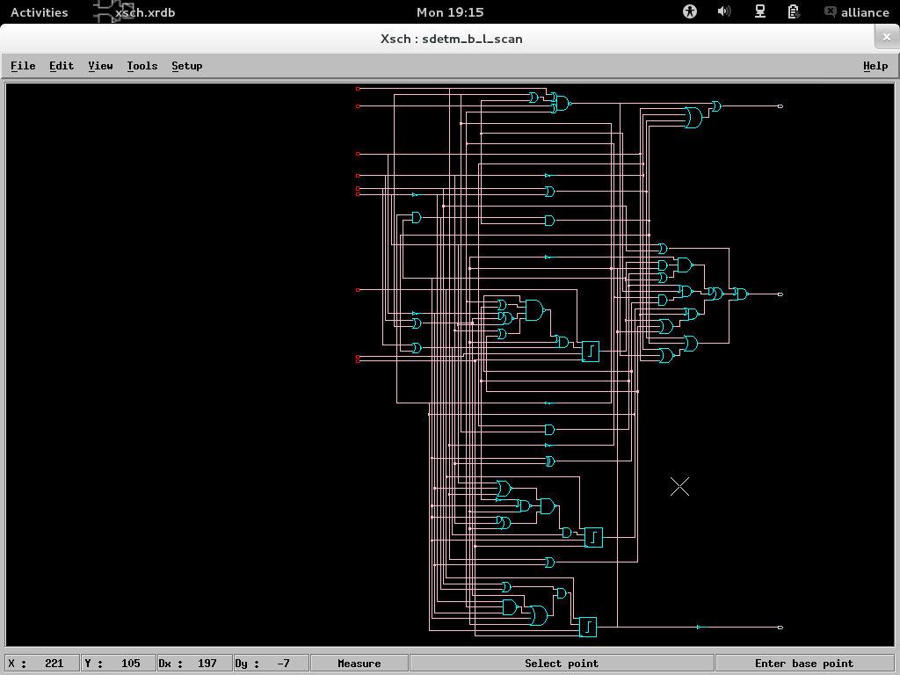

8- Simulation of FSM Using the Behavioural Component, and LOON’s and SCAPIN’s structural Components.

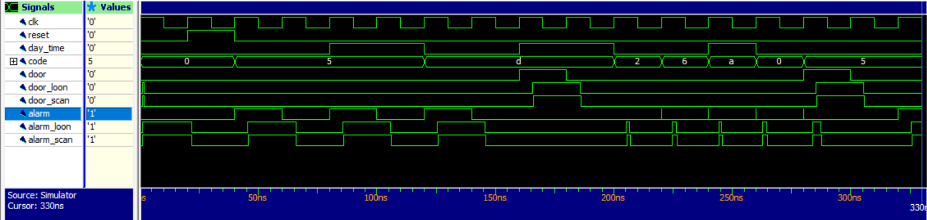

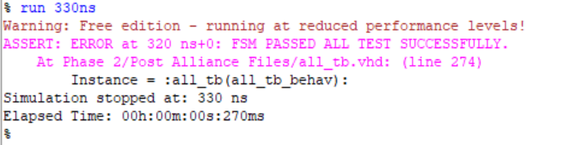

Comments: The Structural Components produced by SCAPIN and LOON have delays unlike the initial behavioural component. These delays, however, cause no problems as they are within half a clock period.

9- Test of scan-path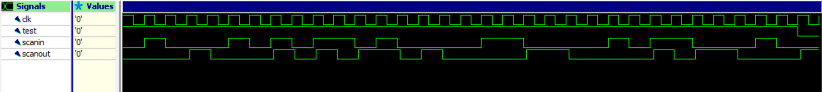

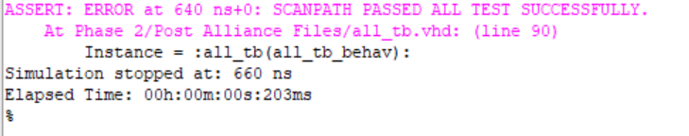

10- Appendix

## Makefile

all_syf: sdeta.vbe \

    sdetj.vbe \

    sdetm.vbe \

    sdeto.vbe \

    sdetr.vbe

        @echo "<-- SYF DONE"

all_boom: sdeta_b.vbe \

    sdetj_b.vbe \

    sdetm_b.vbe \

    sdeto_b.vbe \

    sdetr_b.vbe

        @echo "<-- BOOM DONE"

sdet_boog : sdeta_b.vst \

    sdetj_b.vst \

    sdetm_b.vst \

    sdeto_b.vst \

    sdetr_b.vst

        @echo "<-- BOOG DONE"

sdet_loon : sdeta_b_l.vst \

    sdetj_b_l.vst \

    sdetm_b_l.vst \

    sdeto_b_l.vst \

    sdetr_b_l.vst

        @echo "<-- LOON DONE"

#-------Finite State Machine Synthesis-----------------#

vhd_to_fsm:

    rename .vhd .fsm *.vhd

%_scan.vst : %.vst scan.path

    @echo " scan-path insertion -> $@ "

    scapin -VRB $* scan $*_scan > scapin.out

%_b_l_net.vbe : %_b_l.vst %.vbe

    @echo " Formal checking -> $@ "

    flatbeh $*_b_l $*_b_l_net > $*_flatbeh.out

    proof -d $* $*_b_l_net > $*_proof.out

%.vst : %.vbe paramfile.lax

    @echo " Logical Synthesis -> $@ "

    boog -x 1 -l paramfile $* > $*_boog.out

%_l.vst : %.vst paramfile.lax

    @echo " Netlist Optimization -> $@ "

    loon -x 1 $* $*_l paramfile > $*_loon.out

%_b.vbe: %.vbe

    @echo "     Boolean Optimization -> $@"

    boom -V -d 50 $* $*_b > $*_boom.out

sdeta.vbe: sdet.fsm

    @echo " Encoding Synthesis -> sdeta.vbe"

    syf -CEV -a sdet

sdetj.vbe: sdet.fsm

    @echo " Encoding Synthesis -> sdetj.vbe"

    syf -CEV -j sdet

sdetm.vbe: sdet.fsm

    @echo " Encoding Synthesis -> sdetm.vbe"

    syf -CEV -m sdet

sdeto.vbe: sdet.fsm

    @echo " Encoding Synthesis -> sdeto.vbe"

    syf -CEV -o sdet

sdetr.vbe: sdet.fsm

    @echo " Encoding Synthesis -> sdetr.vbe"

    syf -CEV -r sdet

#-------Clean Up---------------------------------------#

clean :

    rm -f *.out *.vbe *.enc *~

    @echo "Erase all the files generated by the makefile"

## Paramfile

#M{2}

#L{2}

#C{

door:100;

alarm:100;

}

## .Path File

BEGIN_PATH_REG

dac_current_state_0_ins

dac_current_state_1_ins

dac_current_state_2_ins

END_PATH_REG

BEGIN_CONNECTOR

SCAN_IN scanin

SCAN_OUT scanout

SCAN_TEST test

END_CONNECTOR

## FLATBEH Log

@@@@@@@@@ @@@@ @@@@@@@ @@@

@@ @ @@ @ @@ @@ @@

@@ @ @@ @@ @@ @@ @@

@@ @@ @@@@ @@ @@ @@ @@@@@ @@ @@@

@@ @ @@ @@ @ @@@@@@@@ @@ @@ @ @ @@@ @@

@@@@@@ @@ @@ @@ @@ @@@@@@ @@ @@ @@ @@

@@ @ @@ @@@@@ @@ @@ @@ @@@@@@@@@ @@ @@

@@ @@ @@ @@ @@ @@ @@ @@ @@ @@

@@ @@ @@ @@ @@ @@ @@ @@ @ @@ @@

@@ @@ @@ @@@ @@ @ @@ @@ @@ @@ @@ @@

@@@@@@ @@@@@@ @@@@ @@ @@@@ @@@@@@@@ @@@@ @@@@ @@@@

a netlist abstractor

Alliance CAD System 5.0 20090901, flatbeh 5.0 [2000/11/01]

Copyright (c) 1993-2019, ASIM/LIP6/UPMC

Author(s): Fran�ois DONNET, Huu Nghia VUONG

E-mail : alliance-users@asim.lip6.fr

========================= Environnement =========================

MBK_WORK_LIB = .

MBK_CATA_LIB = .:/usr/lib64/alliance/cells/sxlib:/usr/lib64/alliance/cells/dp_sxlib:/usr/lib64/alliance/cells/rflib:/usr/lib64/alliance/cells/rf2lib:/usr/lib64/alliance/cells/ramlib:/usr/lib64/alliance/cells/romlib:/usr/lib64/alliance/cells/pxlib:/usr/lib64/alliance/cells/padlib

MBK_CATAL_NAME = CATAL

============================== Files ==============================

Netlist file = sdetm_b_l.vst

Output file = sdetm_b_l_net.vbe

===================================================================

Loading './sdetm_b_l.vst'

flattening figure sdetm_b_l

loading nao2o22_x1

loading nxr2_x1

loading inv_x4

loading na4_x1

loading ao22_x2

loading oa22_x2

loading inv_x2

loading sff1_x4

loading no3_x1

loading o3_x2

loading o2_x2

loading na2_x1

loading na3_x1

loading a2_x2

loading noa22_x1

loading nao22_x1

loading o4_x2

loading no2_x1

Restoring array's orders

BEH : Saving 'sdetm_b_l_net' in a vhdl file (vbe)

## PROOF LOG

@@@@@@@ @@@

@@ @@ @ @@

@@ @@ @@ @@

@@ @@ @@@ @@@ @@@ @@@ @@

@@ @@ @@@ @@ @@ @@ @@ @@ @@@@@@@@

@@@@@ @@ @@ @@ @@ @@ @@ @@

@@ @@ @@ @@ @@ @@ @@

@@ @@ @@ @@ @@ @@ @@

@@ @@ @@ @@ @@ @@ @@

@@ @@ @@ @@ @@ @@ @@

@@@@@@ @@@@ @@@ @@@ @@@@@@

Formal Proof

Alliance CAD System 5.0 20090901, proof 5.0

Copyright (c) 1990-2019, ASIM/LIP6/UPMC

E-mail : alliance-users@asim.lip6.fr

================================ Environment ================================

MBK_WORK_LIB    = .

MBK_CATA_LIB    = .:/usr/lib64/alliance/cells/sxlib:/usr/lib64/alliance/cells/dp_sxlib:/usr/lib64/alliance/cells/rflib:/usr/lib64/alliance/cells/rf2lib:/usr/lib64/alliance/cells/ramlib:/usr/lib64/alliance/cells/romlib:/usr/lib64/alliance/cells/pxlib:/usr/lib64/alliance/cells/padlib

======================= Files, Options and Parameters =======================

First VHDL file   = sdetm.vbe

Second VHDL file  = sdetm_b_l_net.vbe

The auxiliary signals are erased

Errors are displayed

===============================================================================

Compiling 'sdetm' ...

Compiling 'sdetm_b_l_net' ...

---> final number of nodes = 343(127)

Running Abl2Bdd on `sdetm_b_l_net`

--------------------------------------------------------------------------------

Formal proof with Ordered Binary Decision Diagrams between

'./sdetm' and './sdetm_b_l_net'

--------------------------------------------------------------------------------

============================== PRIMARY OUTPUT ===============================

============================= AUXILIARY SIGNAL ==============================

============================== REGISTER SIGNAL ==============================

=============================== EXTERNAL BUS =================================

================================ INTERNAL BUS =================================

Formal Proof : OK

pppppppppppppppppppppppprrrrrrrrrrrrooooooooooooooooooooooooooooofffffffffffffff

--------------------------------------------------------------------------------

## LOON’s and SCAPIN’s Structural Components and FSM’s Behavioural Component Comparison-Based-Testbench

entity all_tb is

end all_tb;

architecture all_tb_behav of all_tb is

component dac is

port (

reset : in bit;

day_time : in bit;

code : in bit_vector(3 downto 0);

door : out bit;

alarm : out bit;

clk : in bit;

vdd : in bit;

vss : in bit

);

end component dac;

component dac_loon is

port (

reset : in bit;

day_time : in bit;

code : in bit_vector(3 downto 0);

door : out bit;

alarm : out bit;

clk : in bit;

vdd : in bit;

vss : in bit

);

end component dac_loon;

component dac_scan is

port (

reset : in bit;

day_time : in bit;

code : in bit_vector(3 downto 0);

door : out bit;

alarm : out bit;

clk : in bit;

vdd : in bit;

vss : in bit;

scanin : in bit;

test : in bit;

scanout : out bit

);

end component dac_scan;

signal reset : bit;

signal day_time : bit;

signal code : bit_vector(3 downto 0);

signal door : bit;

signal alarm : bit;

signal door_loon : bit;

signal alarm_loon : bit;

signal door_scan : bit;

signal alarm_scan : bit;

signal clk : bit;

signal vdd : bit := '1';

signal vss : bit := '0';

signal scanin : bit := '0';

signal test : bit := '0';

signal scanout : bit := '0';

for all : dac use entity work.dac(dac_behav);

for all : dac_loon use entity work.sdetm_b_l(structural);

for all : dac_scan use entity work.sdetm_b_l_scan(structural);

constant clk_period : time := 20 ns;

constant a : bit_vector(3 downto 0) := "1010";

constant b : bit_vector(3 downto 0) := "1011";

constant o : bit_vector(3 downto 0) := "1101";

constant scantest : bit_vector := "01000101011010000110000101100010";

begin

dut : dac port map(reset, day_time, code, door, alarm, clk, vdd, vss);

dut_loon : dac_loon port map(reset, day_time, code, door_loon, alarm_loon, clk, vdd, vss);

dut_scan : dac_scan port map(reset, day_time, code, door_scan, alarm_scan, clk, vdd, vss, scanin, test, scanout);

process begin

test <= '1';

for i In 0 to scantest'length-1 loop

scanin <= scantest(i);

wait for clk_period;

if i>=2 then

Assert scanout=scantest(i-2)

Report "scanout does not follow scan in"

Severity error;

end if;

end loop;

assert false

report "SCANPATH PASSED ALL TEST SUCCESSFULLY."

severity error;

test<= '0';

wait for clk_period;

-- 1

reset <= '1';

-- day_time<='0';

-- code <= x"";

wait for clk_period;

assert door = door_loon and alarm = alarm_loon

report "door_loon != door OR alarm_loon != alarm. Setting reset = 1 should reset the circuit to its initial state"

severity failure;

assert door = door_scan and alarm = alarm_scan

report "door_scan != door OR alarm_scan != alarm. Setting reset = 1 should reset the circuit to its initial state"

severity failure;

-- 2

reset <= '0';

day_time <= '0';

code <= x"5";

wait for clk_period;

assert door = door_loon and alarm = alarm_loon

report "door_loon != door OR alarm_loon != alarm. Entering a wrong code, should trigger the alarm"

severity failure;

assert door = door_scan and alarm = alarm_scan

report "door_scan != door OR alarm_scan != alarm. Entering a wrong code, should trigger the alarm"

severity failure;

-- 3

wait for clk_period;

assert door = door_loon and alarm = alarm_loon

report "door_loon != door OR alarm_loon != alarm. Waiting for a clock cycle, should reset both door and alarm, to zero"

severity failure;

assert door = door_scan and alarm = alarm_scan

report "door_scan != door OR alarm_scan != alarm. Waiting for a clock cycle, should reset both door and alarm, to zero"

severity failure;

-- 4

reset <= '0';

day_time <= '1';

code <= x"5";

wait for clk_period;

assert door = door_loon and alarm = alarm_loon

report "door_loon != door OR alarm_loon != alarm. Entering a wrong code, even during daytime should trigger the alarm"

severity failure;

assert door = door_scan and alarm = alarm_scan

report "door_scan != door OR alarm_scan != alarm. Entering a wrong code, even during daytime should trigger the alarm"

severity failure;

-- 5

wait for clk_period;

assert door = door_loon and alarm = alarm_loon

report "door_loon != door OR alarm_loon != alarm. Waiting for a clock cycle, should reset both door and alarm, to zero"

severity failure;

assert door = door_scan and alarm = alarm_scan

report "door_scan != door OR alarm_scan != alarm. Waiting for a clock cycle, should reset both door and alarm, to zero"

severity failure;

-- 6

reset <= '0';

day_time <= '0';

code <= o;

wait for clk_period;

assert door = door_loon and alarm = alarm_loon

report "door_loon != door OR alarm_loon != alarm. Entering 'O' during night time should trigger the alarm"

severity failure;

assert door = door_scan and alarm = alarm_scan

report "door_scan != door OR alarm_scan != alarm. Entering 'O' during night time should trigger the alarm"

severity failure;

-- 7

wait for clk_period;

assert door = door_loon and alarm = alarm_loon

report "door_loon != door OR alarm_loon != alarm. Waiting for a clock cycle, should reset both door and alarm, to zero"

severity failure;

assert door = door_scan and alarm = alarm_scan

report "door_scan != door OR alarm_scan != alarm. Waiting for a clock cycle, should reset both door and alarm, to zero"

severity failure;

-- 8

reset <= '0';

day_time <= '1';

code <= o;

wait for clk_period;

assert door = door_loon and alarm = alarm_loon

report "door_loon != door OR alarm_loon != alarm. Entering 'O' during daytime should open the door"

severity failure;

assert door = door_scan and alarm = alarm_scan

report "door_scan != door OR alarm_scan != alarm. Entering 'O' during daytime should open the door"

severity failure;

-- 9

wait for clk_period;

assert door = door_loon and alarm = alarm_loon

report "door_loon != door OR alarm_loon != alarm. Waiting for a clock cycle, should reset both door and alarm, to zero"

severity failure;

assert door = door_scan and alarm = alarm_scan

report "door_scan != door OR alarm_scan != alarm. Waiting for a clock cycle, should reset both door and alarm, to zero"

severity failure;

-- 10

reset <= '0';

day_time <= '0';

code <= x"2";

wait for clk_period;

assert door = door_loon and alarm = alarm_loon

report "door_loon != door OR alarm_loon != alarm. Entering 2 neither opens the door, nor triggers the alarm"

severity failure;

assert door = door_scan and alarm = alarm_scan

report "door_scan != door OR alarm_scan != alarm. Entering 2 neither opens the door, nor triggers the alarm"

severity failure;

-- 11

reset <= '0';

day_time <= '0';

code <= x"6";

wait for clk_period;

assert door = door_loon and alarm = alarm_loon

report "door_loon != door OR alarm_loon != alarm. Entering 2, 6 neither opens the door, nor triggers the alarm"

severity failure;

assert door = door_scan and alarm = alarm_scan

report "door_scan != door OR alarm_scan != alarm. Entering 2, 6 neither opens the door, nor triggers the alarm"

severity failure;

-- 12

reset <= '0';

day_time <= '1';

code <= a;

wait for clk_period;

assert door = door_loon and alarm = alarm_loon

report "door_loon != door OR alarm_loon != alarm. Entering 2, 6, A neither opens the door, nor triggers the alarm, switching daytime to 1 and not pressing 'O' , will not open the door nor trigger the alarm"

severity failure;

assert door = door_scan and alarm = alarm_scan

report "door_scan != door OR alarm_scan != alarm. Entering 2, 6, A neither opens the door, nor triggers the alarm, switching daytime to 1 and not pressing 'O' , will not open the door nor trigger the alarm"

severity failure;

-- 13

reset <= '0';

day_time <= '0';

code <= x"0";

wait for clk_period;

assert door = door_loon and alarm = alarm_loon

report "door_loon != door OR alarm_loon != alarm. Entering 2, 6, A, 0 neither opens the door, nor triggers the alarm"

severity failure;

assert door = door_scan and alarm = alarm_scan

report "door_scan != door OR alarm_scan != alarm. Entering 2, 6, A, 0 neither opens the door, nor triggers the alarm"

severity failure;

-- 14

reset <= '0';

day_time <= '0';

code <= x"5";

wait for clk_period;

assert door = door_loon and alarm = alarm_loon

report "door_loon != door OR alarm_loon != alarm. Entering 2, 6, A, 0, 5 opens the door, but doesn't trigger the alarm"

severity failure;

assert door = door_scan and alarm = alarm_scan

report "door_scan != door OR alarm_scan != alarm. Entering 2, 6, A, 0, 5 opens the door, but doesn't trigger the alarm"

severity failure;

-- 15

wait for clk_period;

assert door = door_loon and alarm = alarm_loon

report "door_loon != door OR alarm_loon != alarm. Waiting for a clock cycle, should reset both door and alarm, to zero"

severity failure;

assert door = door_scan and alarm = alarm_scan

report "door_scan != door OR alarm_scan != alarm. Waiting for a clock cycle, should reset both door and alarm, to zero"

severity failure;

assert false

report "FSM PASSED ALL TEST SUCCESSFULLY."

severity error;

wait;

end process;

process begin

clk <= '1', '0' after (clk_period/2);

wait for clk_period;

end process;

end architecture all_tb_behav;